SUMMER CAMP DENMARK 1970

CURLEW PATROL LOG

DENMARK ‘70

CURLEW PATROL*
P.L. A. Anderson
A.P.L. J. McCallum
1st Scout C. Wilson
2nd Scout G. Knight
3rd Scout J. Allan
Last Scout D. McIntyre

Editorial Note
* References to the King-Curlew Patrol indicate that Scouts from the Kingfisher and Curlew Patrol were in the patrol

Monday 3/7/70 King Curlew Patrol Log

We arrived at the scout headquarters at about 11 o’clock. Before we left, Mrs. Hall took a picture of us. The bus was about half an hour late. On the bus, Rusty polluted the atmosphere and made a mess of the floor, I ask you. The bus journey was long, steamy with only one stop for the needy. We arrived at the boat at 4:10 and 25.99963 seconds (Curlew exactness) after much confusion owing to the Scouters sense of direction (or lack of).
We arrived at our luxuriously cramped cabin on board the Princessen. For our tea, we had such good food that we wanted to go home being entirely cheesed off (or off cheese).
After tea, we had free time till 10.15 when we were supposed to be in our cabins. In the cabin, the first problem was how one used the downie and the little black bell. Some slept under the Downie, some slept in it, some on top and some nameless rioters didn’t sleep at all.
Night night.
Author: Gordon Knight 3rd Scout.

Tuesday 4/8/70 King-Curlew

This morning, we crawled tired (radial x or Michelin you groundhog).
For breakfast we had cornflakes and milk which came from no cow ‘man’. After breakfast our room (was) raided, first by maids then Scouters.
At 11:30 or (there) about we had to be assembled on the sun deck where we were discouraged from rioting. After that, we had free time till lunch where we had to eat a big meal because we had been told the boat would arrive two hours late, two our horror. Thus we would not eat again till 1030.
The boat arrived at the port at about 3.00 and we took ‘a long journey on a fast train’ to the boat train. It was two hours in which we talked and played about, before we reached the boat train or the ‘trained boat’. The boat took us across a river* which took one hour. An hour later, we reached Copenhagen station. Some Danish Scouters then took us to our (campsite), where after lunch**, we went to bed***.
Authors: John McCallum (APL) and Donald MacIntyre (2nd Scout)

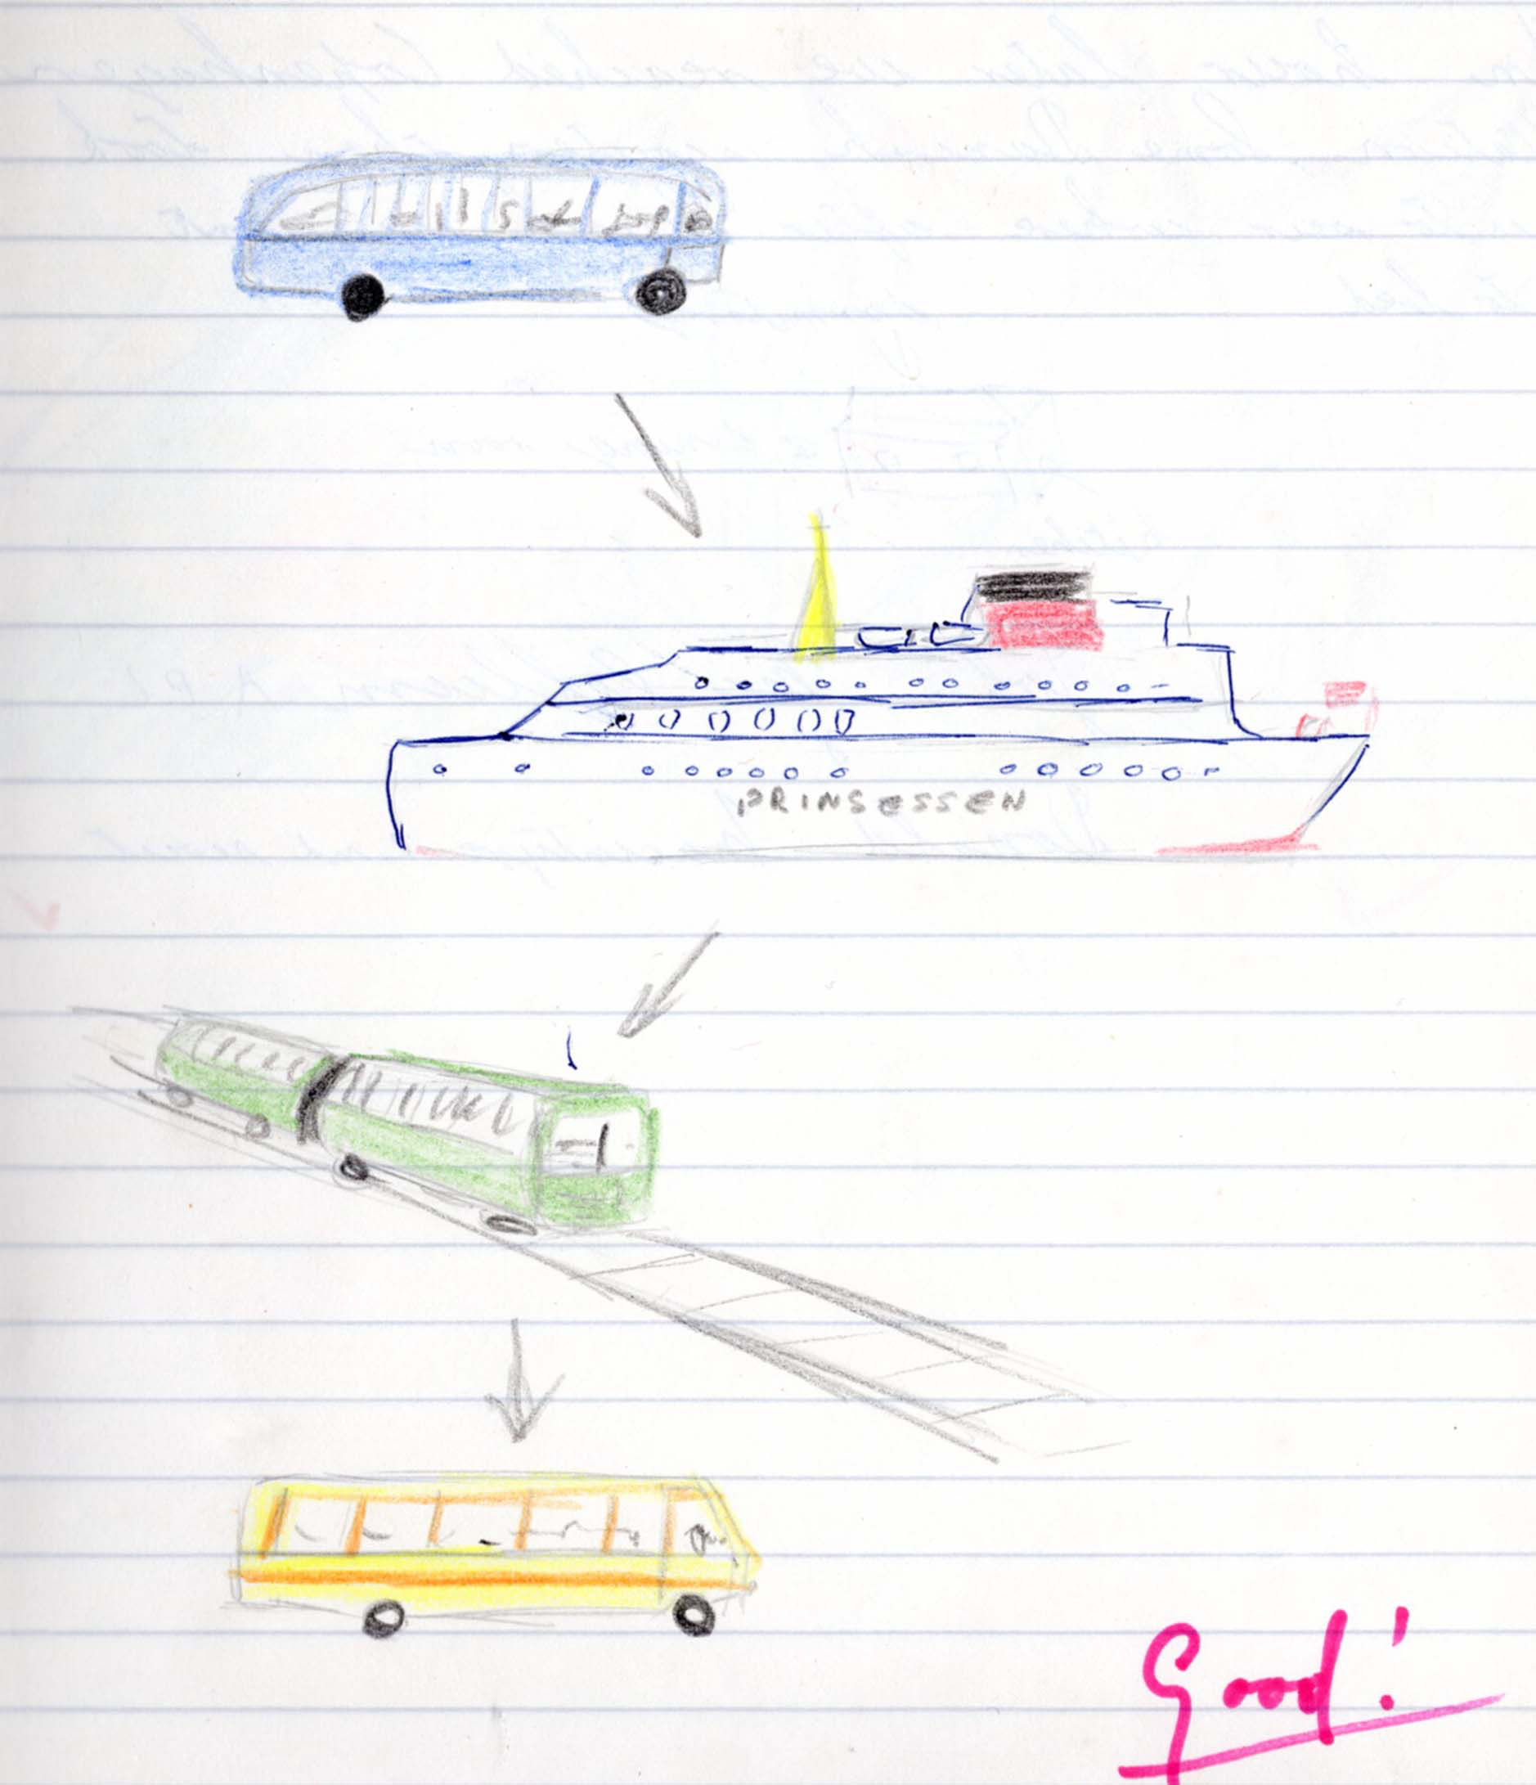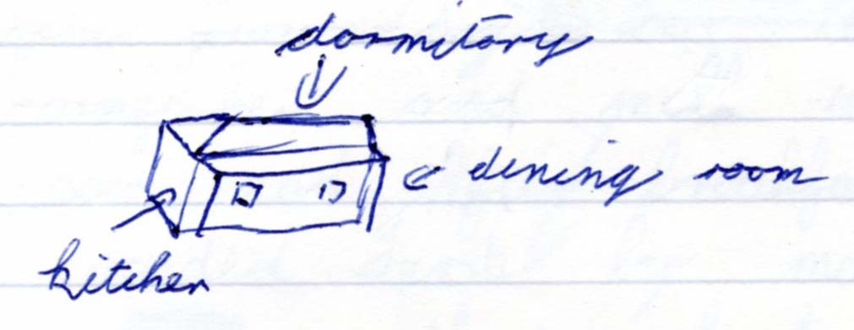

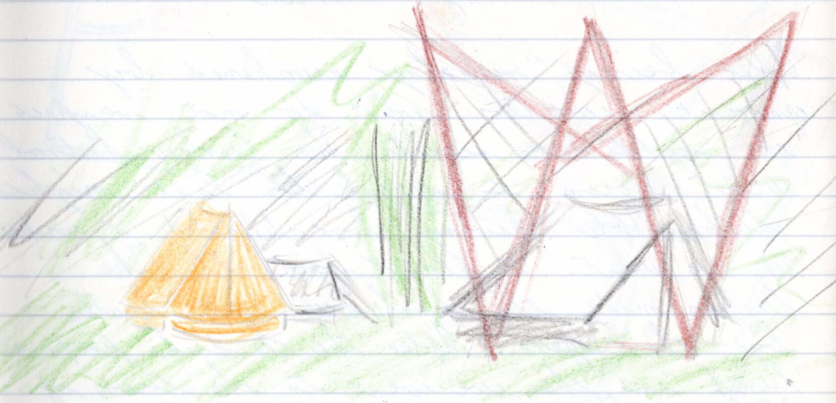

Editorial Notes
*The ’river’ was actually a strait between two islands, with the boat sailing from Nyborg to Korsor. A bridge has now replaced the boat train.
** More like supper
*** The dormitory was actually the attic of the camp hut. From memory, this was used by the Scouts throughout the camp apart from the time spent with host families. The leaders did not sleep in the dormitory and might have slept in tents. A hike tent was present which might have been used by the ladies. A patrol tent (possibly lent by the Danish troop) was also present and may have been used by the Scouters.

Wednesday 5/8/80 King-Curlew Duty Patrol Curlew

After being rudely awakened by ignorant Scouters who do not respect the rights of Scouts, the Curlew Patrol went down to wash the last night’s dishes.
After having breakfasted and washed up, we went to play football. The Curlews made the final but were beaten by the Tigers.
After this, the Ducks* prepared lunch and then we went to the town of Volidas.** Then we came back, had tea, washed up, and went to bed.

Author John McCallum APL

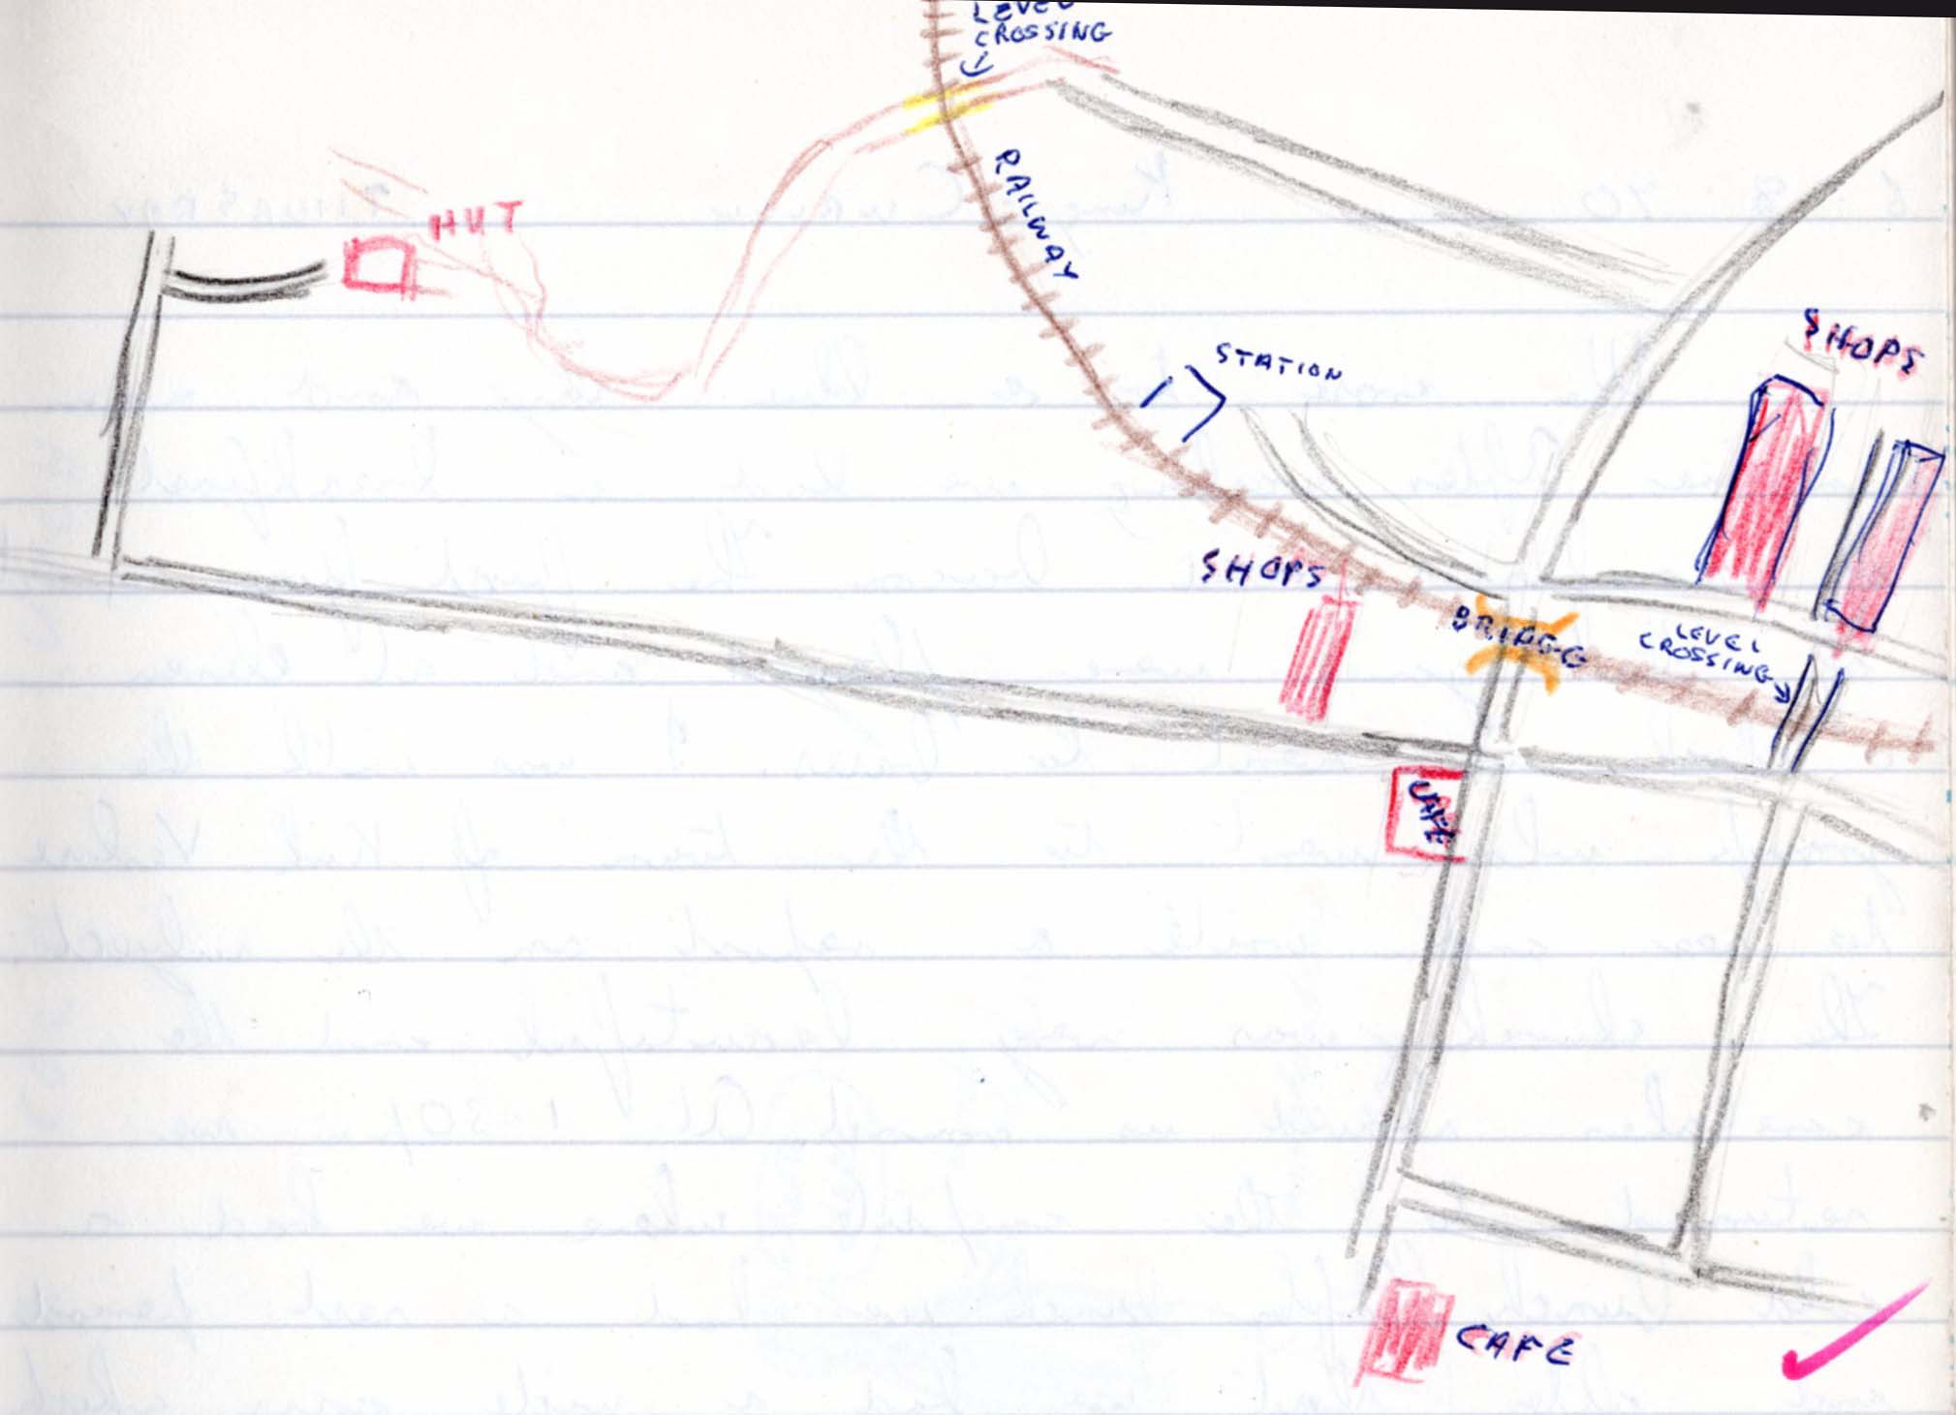

Editorial Notes
* The Duck Patrol
** Vaerlos

Thursday 6/8/70 King-Curlew

We arose to a blue sky and warm sunshine. After washing, we had a breakfast of cornflakes and bacon. The first four rounds of the game were played and at 11 o’clock we went to bases. I was with the group who went to the town of Kirk Verlose to see and write a report on the subject. The church was very beautiful and the caretaker showed us round.*
At 1.30 p.m., we returned to the campsite where we had a cold lunch.
After lunch, we had a rest period and after that we had a wide game which the Curlew won.
We then had the last round of the game between the Tiger and the Sox**. The Tiger won. We then drew stores for our dinner of mince balls and potatoes followed by rice pudding and peaches.
After dinner, we had testing and bases which was followed by campfire, then pit.

Author Alan Anderson (P.L. Curlew)

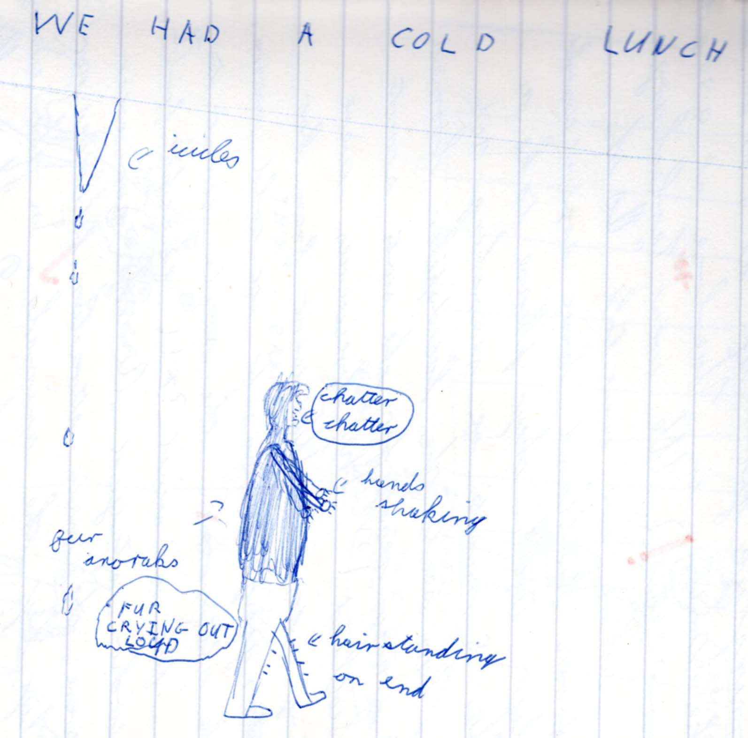

Editorial Note
* A description of the church was written by John Bruce for one of his ASS tests and can be read on the Web site
** This was presumably an amalgamation of the Fox and Seagull patrols.

Friday 7/8/70 Curlew

This morning, we got up at 7:30 AM to catch the train in Vaerlose at 9:30 AM (it’s ‘snore’ fair).
We went (to) Carlsberg Breweries where are we were told, “As the scouts from Scotland have arrived too early, will they please take a seat. “
After five minutes of searching and fighting for seats, the loudspeaker boomed. “ We are now ready for the scouts from Scotland!”
The breweries were interesting inside. We went from hot rooms and ponging* rooms, to ice cold rooms.
In the afternoon, the scouts went to the zoo for a visit except for A Riddle who stayed**. At the zoo, our kilts were the main attraction followed not too closely by the animals.
In the evening, we went to stay with our Danish families.

Author John McCallum

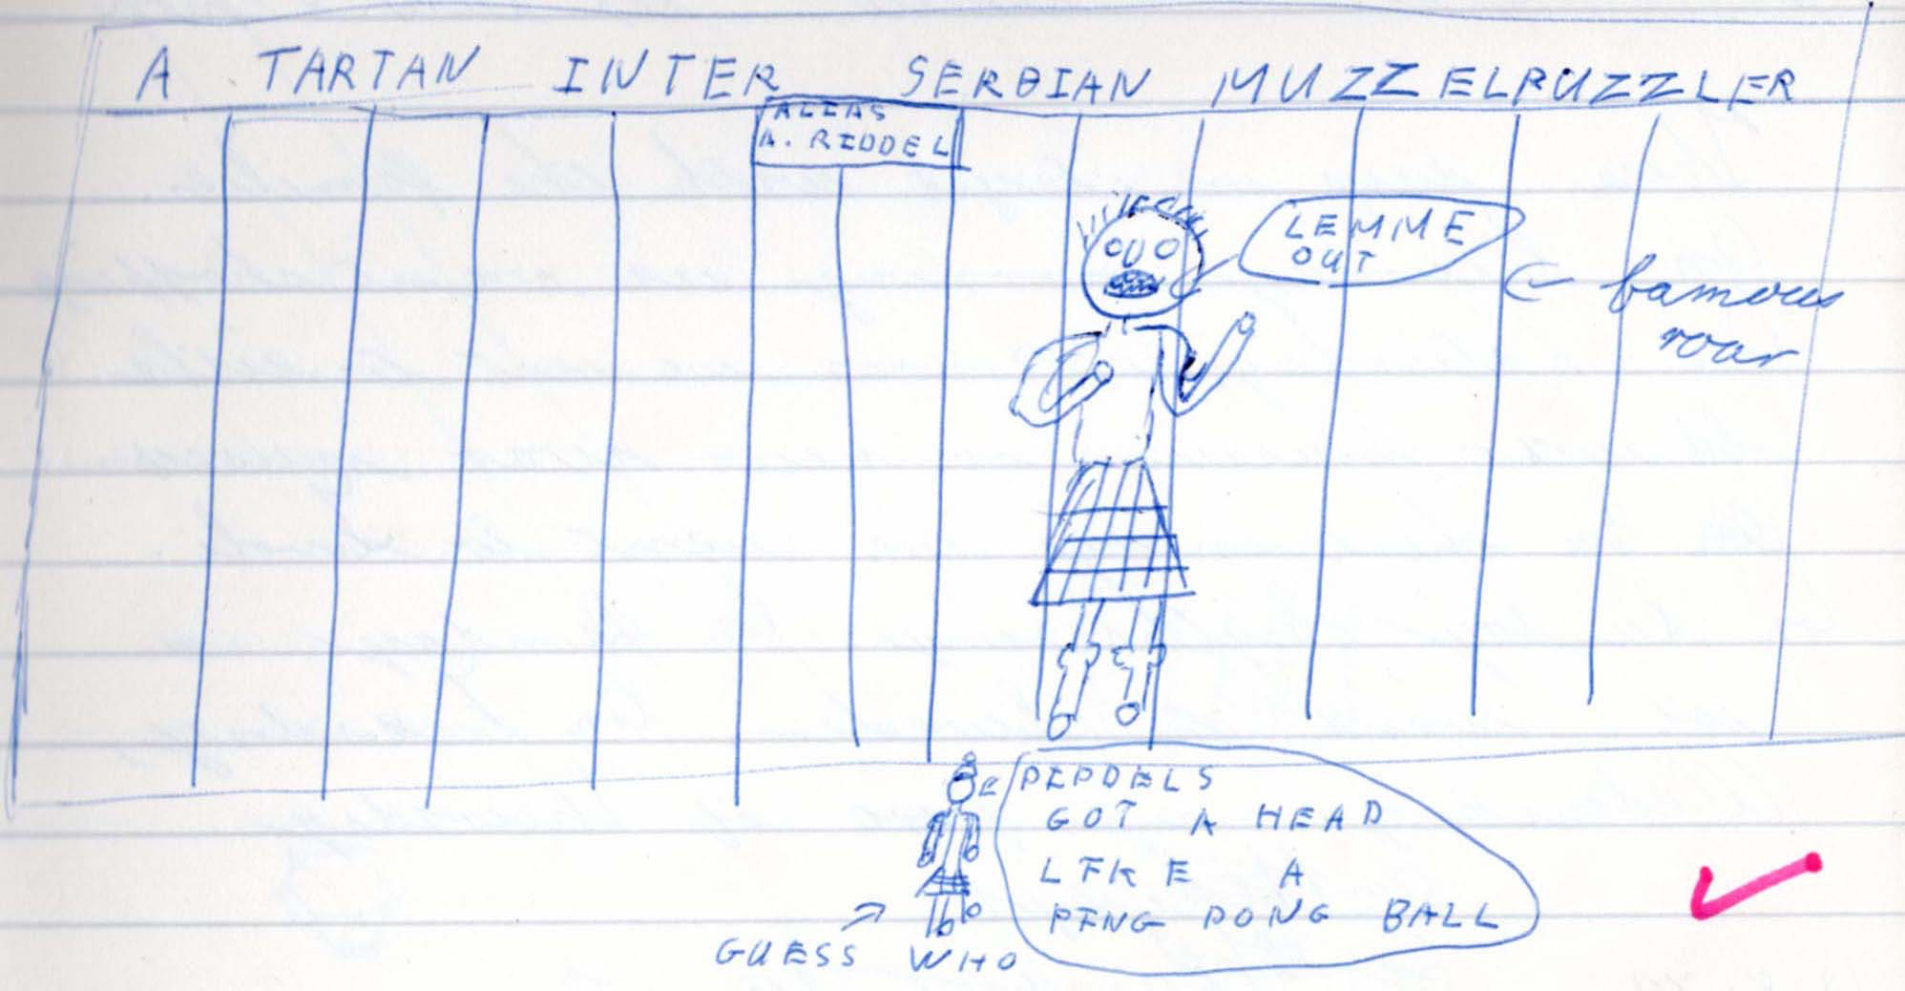

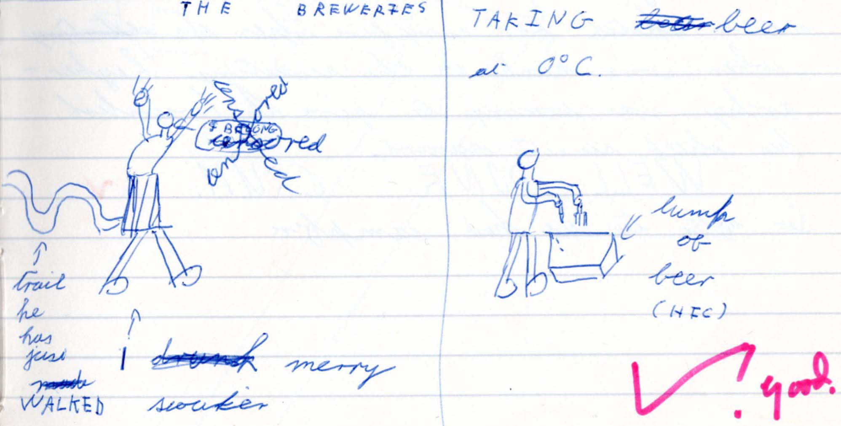

Editorial notes
* Looks like ponging but not 100% sure
** See sketches
Saturday 8/9/70 – Monday 10/8/70
(For) these days, we stayed with the families.
On Saturday morning, we went shopping. On Saturday afternoon we went to either (the) old War Museum or new War Museum.*
In the evening, we went to Tivoli.

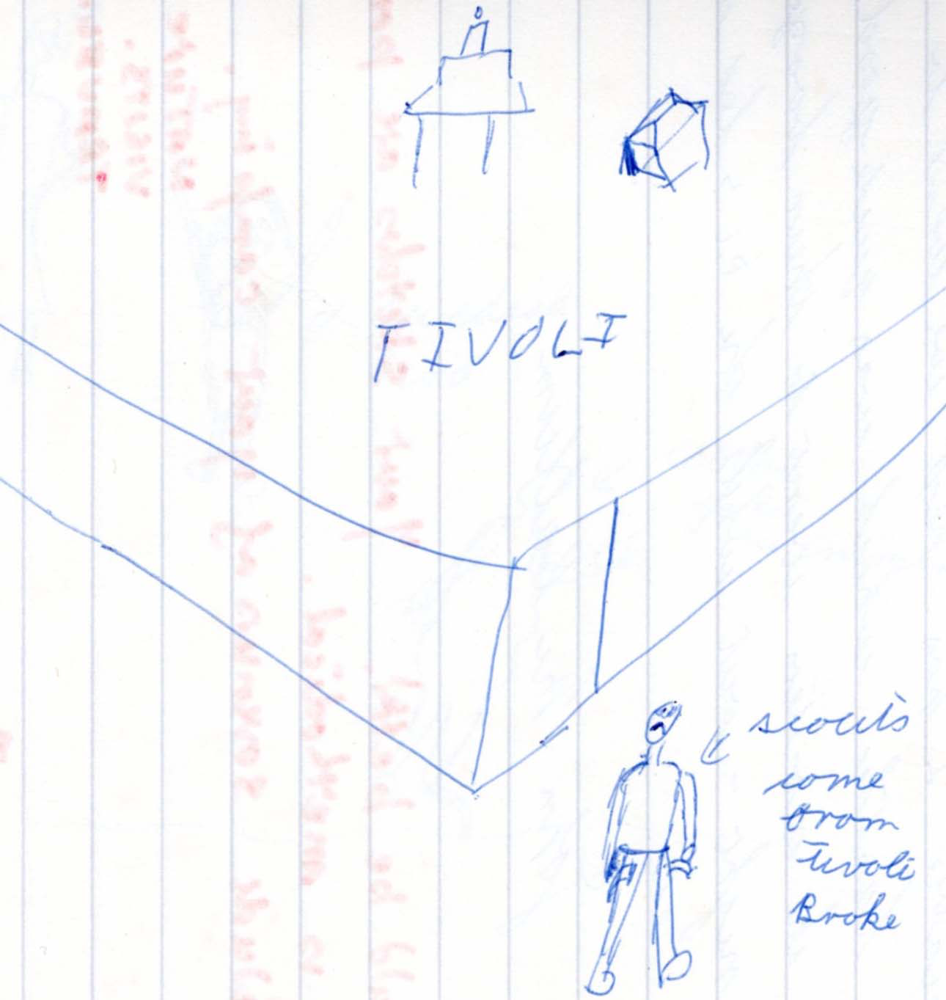

On Sunday sightseeing.*
On Monday we went to Sweden.**

Editorial notes
* It is likely that the Scouts spent Saturday and Sunday exploring Copenhagen with their relevant host families and so the visits and activities might have varied.
** This was as a troop rather than with host families. It rained all day.

Tuesday 11/8/70 – Thursday 13/8/70

On Tuesday, Wednesday and part of Thursday hiking*

Editorial note
* This was a 3-day 30 mile hike carried out by small groups of 5 or 6 Scouts taking different routes and camping in different places. The younger Scouts stayed in camp.

Thursday 13/8/70
(In the afternoon), we had free time till 3.30 when we worked out a sketch for campfire when some kink in the Scouting hierarchy what’s coming to give A. Crumlish his Chief Scout’s Award.
WELL DONE CRUM
So after tea we had campfire.

Friday 14/8/70 Curlew
We got up at 08.00 hours, had breakfast, and went to Frederiksburg Castle ( the most boring dump on earth) and at 13:00 hours we went to the beach where we spent an enjoyable two hours.
Next we went to Hamlet’s Castle which was quite good.
After tea, the Scouters went to their booze up, sorry night out,* while the PLs led a campfire etc

Author John McCallum

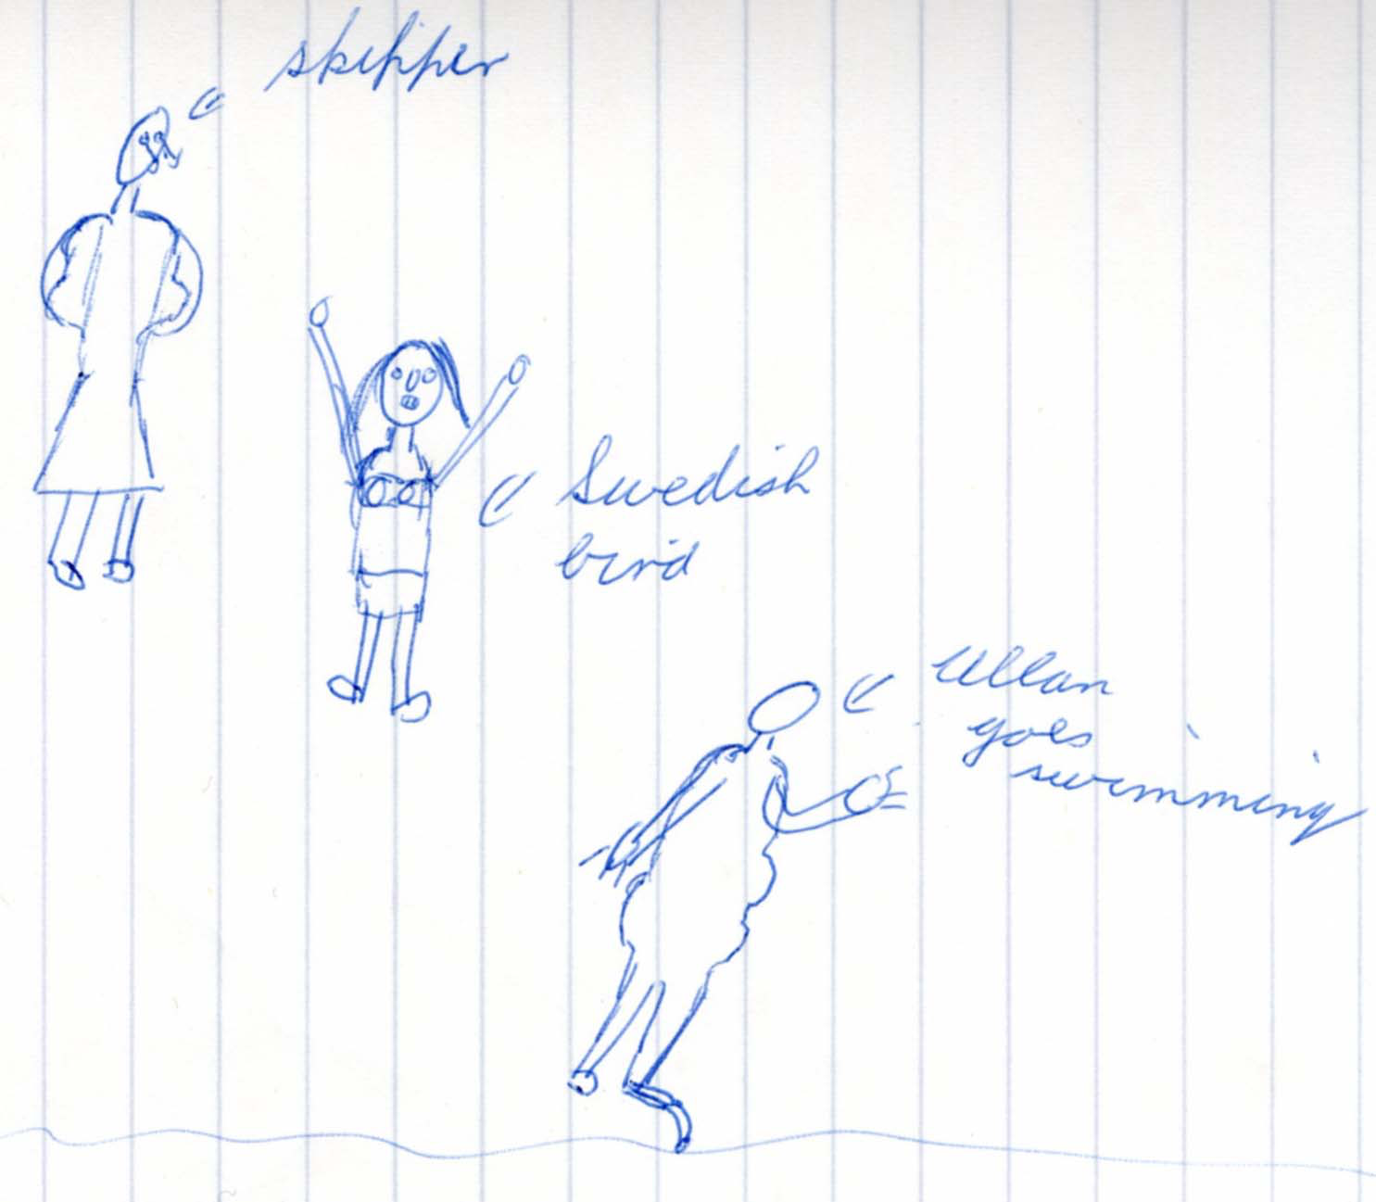
Editorial note
*A photograph suggests that this might have been an outdoor meal at a restaurant - possibly one of the cafes identified in the earlier sketch map

Saturday 15th –Monday 17th August 1970
The log provides no information on the final three days.

