Glip’s Log Book Entry for the 18th-20th June, 1982.
Sunrise Climb and Ben Donich.
The Party: Glip¹
PL Kevin Byng². PL Andrew Wilson³. PL Graham Bolster⁴.
PL Colin Roach⁵. APL Andrew Davies⁶. Kenneth Blair⁷.
Stuart Dalrymple^{8.} Ian McDonald⁹. Robert Wright¹⁰.
Richard Barclay¹¹?¹²
Friday 18th June, 1982.
We left in Mr. Blair’s van¹³ at 7.30 pm from HQ¹⁴. The arrangements were for everybody to arrange their own camping gear and food. Cost for van and site = £2.50¹⁵. We had hoped to do the sunrise climb¹⁶ when we arrived, but the weather was cloudy and unpromising, so we pitched camp¹⁷ then retreated from the midges by going into Arrochar and then Tarbet. ^{17b}

Saturday 19th June, 1982.
The midges were bad again and I made my breakfast in the van. Kevin², Shrew⁵, Ralj³, Toad⁶, Rivet⁴ and Frodo⁷ opted to join me in climbing Ben Donich¹⁸, while the others chose to stay in camp to reserve their strength.
We climbed Ben Donich up the north shoulder after Rivet had led us a merry route through the forest¹⁹. Frodo²⁰ found the going tough and was thankful when we stopped for lunch about halfway up. During lunch, hats flew in all directions, there was an orange peel fight; my balaclava was thrown down the mountain and rucsacs went walkies. The upshot of the battle was a desperate flight to safety by myself, pursued fiercely by Rivet. Thus, I arrived at the summit first, after a bit of a sprint ascent. Shrew and Riv appeared on the scene next, so we made peace and planned a muddy clod²¹ attack on the rest when they came. This didn't quite work out as planned since Kevin slipped through the lines and disrupted our plan. Nevertheless, a battle royal did take place with everybody getting filthy with mud and other things²². Before things went too far, we held a peace conference at the trig point which gradually evolved into a Glip slagging match as far as K. Byng was concerned. The now infamous KB guffaw was put to good use²³.
On the descent, we played amongst the rocks and crevasses on the north side of the mountain²⁴, much to Shrew’s disapproval²⁵. Daring crevasse leaps and rock scrambles occupied a great deal of time.
Eventually, we got back to the van after one of our madder climbs and returned to camp, collecting wood for the campfire on route. Due to the evil midges, the fire was lit almost immediately, and people worked as close to the fire as possible. Washing up was torture and as soon as it was done, we drove into town to escape for a while and also to find toilets. The plush Arrochar loos²⁶ were closed in fact, so we continued to Tarbet. Here, we found the Lomond Buttery²⁷ open, so several of the party entered for tea and cakes. It must have looked distinctly odd – grubby, smelly (Dettol) ²⁸ Scouts in hiking boots drinking tea in a nicely carpeted tearoom. The toilet visitors²⁹ arrived just as the door was locked and made a nuisance of themselves by staring in the window. Naturally, K. Byng pressed his nose against the pane and adopted the ‘pained’ expression until the waitresses relented and let them in. During this refreshment, we had a toddler in front of us who kept laughing at Toad and me. Maybe it was because of the silly grins we gave it. Possibly.
We stopped to inform the police of our plans³⁰ on the way back to the campsite and then rebuilt the fire. Slowly, the younger Scouts, except for Frodo, lost interest in the sunrise climb and retreated to pit. Toad, too, retired to pit, but due to a migraine attack in his case.
So, it was Shrew, Riv, Frodo, Kevin, Ralj and myself who set off on a cloudy, warm, dry evening up the steep W slopes of the Cobbler just after midnight³¹. It was a slow, sleepy ascent with Frodo being the most tired, naturally enough³². Kevin set the pace with Frodo behind him and that seemed to work quite well. I can't remember who did the compass work³³, but we hit the summit bang on, almost. We were in fact slightly left and so missed all the rocks. We bivvied down on the gentle N grassy slope just below the summit on top of Karrimor bags³⁴. I woke about sunrise, but it was pretty feeble so I didn't wake the others. ³⁵
Rain began about 7 am, so we left our bivvy spot and descended to the van, disappointed at not getting a decent sunrise but happy that we actually managed to bivvy out on top. At least, I was.
It was pouring when we reached the van, so we drove straight into Arrochar and I treated everybody to a cup of tea and a scone³⁶. The cooked breakfast was too tempting, and I yielded, causing great jealousy amongst my companions.
At 10.00, we left a note of our return at the police station³⁰ and returned reluctantly to camp where the others were already up and had breakfasted. I treated Toad to an ice lolly at the campsite shop³⁷ to make up for his migraine attack and as a thank you for watching the camp.
I got shouted at by the camp warden for hurdling a fence. ³⁸ Very embarrassing, but we made-up.
Toad, Kevin and I had a game of pooh sticks³⁹ after I'd phoned KWP⁴⁰ urging him to come as soon as possible. The van couldn't take everybody and a car had been needed as well. Peter⁴¹ had done the needful on Friday and KWP was coming up today.
I held a Scouts Own⁴² on the shore away from the worst of the midges on the theme- things can only get better! For the rest of the day, we played about with the football although the younger element of our party just got depressed and grumpy. KWP arrived just as the midges got really bad again.
To sum up, the weekend was spoilt by midges and one wonders whether there’s ever going to be an answer to these pests.
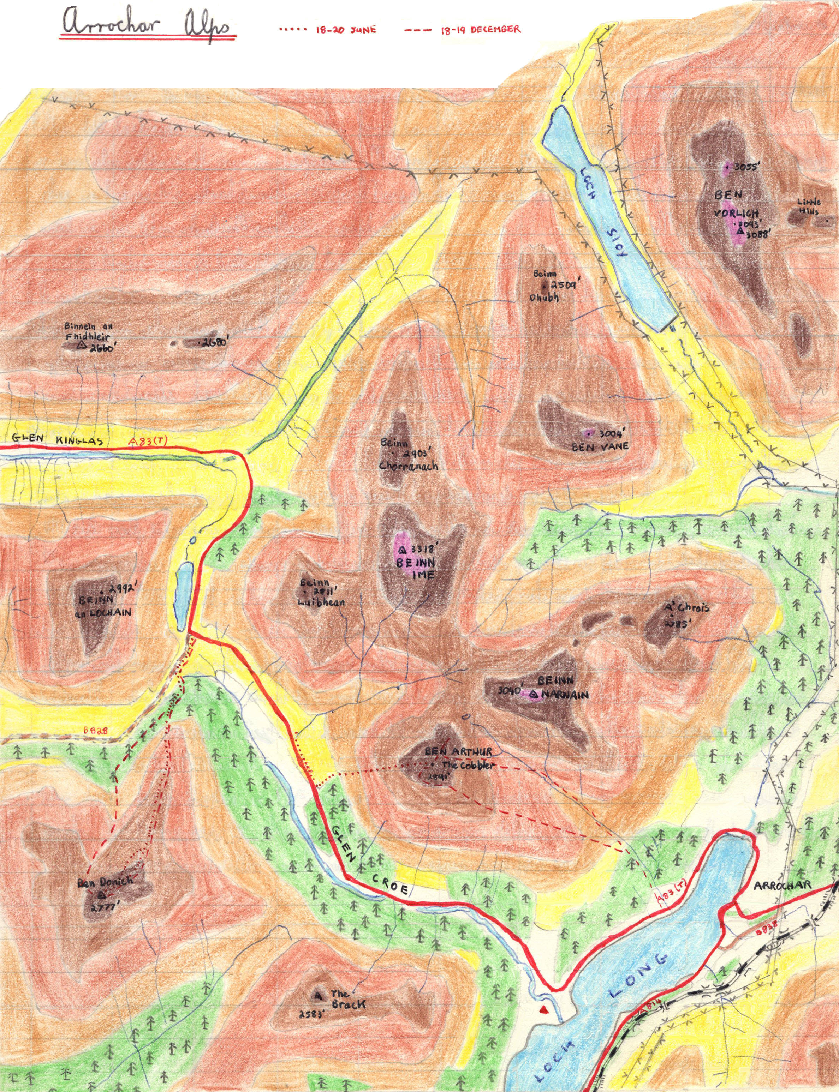

Additional Comments for 18th-20th June 1982
1. Graham L. Patrick (Glip) was a Wolf Cub and Boy Scout with the 70th Renfrewshire from about 1962 to 1970, and was then a Venture Scout in the Cloch Venture Scout Unit until 1974. He then rejoined the 70th Renfrewshire as an Assistant Scout Leader at the same time as Kenneth W. Paton.
2. Kevin Byng (Kev) joined the troop in March 1978 and was PL of the Falcon Patrol from 1981-1983. Kevin spent a long weekend at the Pitlochry Summer Camp of 1977 when he was a Cub, then attended every summer camp from 1978 to 1983. In 1981, he gained the honour of being declared Camp Twit at the summer camp held at Coldstream. When Kevin was aged 12, he completed the Everest Challenge held in 1979. He was probably aged 15 during the summer of 1982. Kevin had a wicked sense of humour, which included the potentially dangerous habit of ‘winding up’ Graham Bolster (Rivet). He moved up to the Venture Scouts in September 1983.
3. Andrew Wilson (Ralj/Raljex/Ralg/Ralgex/Andrex) joined the Troop in March 1977 at the age of 10.5 and was PL of the Kingfisher Patrol from 1980-1982, He was also appointed SPL for the 1981-82 Scout session. Ralj attended every Summer Camp from 1977 to 1982 and was Patrol Leader at Coldstream and Aberdeen. He also completed the Everest Challenge held in 1979. Ralj may have gained his nickname at the Pitlochry Summer Camp of 1977. Originally, he was nicknamed ‘Andrex’, but this was eventually modified to ‘Raljex’. Andrew probably preferred to be associated with an analgesic spray (Ralgex) than a brand of toilet roll (Andrex). It’s not known whether there was any significance to him being initially nicknamed Andrex, other than it was close to his actual name. At the end of August 1982, Ralj joined the Venture Scout Unit. He was aged about 16 during the summer of 1982.
4. Graham Bolster (Riv, Rivet) joined the troop in November 1977 and was aged about 16 during the summer of 1982. He was promoted to PL of the Eagle Patrol after the summer of 1981 for the 1981-82 session. He attended every summer camp from 1978 to 1982 and was PL of the Eagle Patrol at his final Summer Camp at Templar’s Park. Graham was the only Scout to achieve a ‘Double Everest’ during the Everest Challenge held in 1979. It is believed that Graham may have gained his nickname at Logie Summer Camp in 1978 because his name ‘Bolster’ resembled ‘Bolter’, which signified a ‘Riveter’. Graham’s nickname stuck and he is still called Riv or Rivet (as of 2024). Graham joined the Venture Scouts after the summer of 1982, then returned to the troop as an Assistant Scout Leader for several years.
5. Colin Roach (Shrew) joined the troop in March 1977 and turned 16 during the summer of 1982. By that time, he had been PL of the Seagull Patrol for two years (1980-82). Colin attended every Summer Camp from 1977-1982 and had been PL at both Coldstream and Templar’s Park. He also achieved his Everest Certificate during the Everest Challenge held in 1979. It is believed that he gained his nickname at the Summer Camp held at Logie in 1977, but the reason for him gaining his nickname has not been recorded. Colin joined the Venture Scouts at the end of the summer of 1982.
6. Andrew Davies (Toad) joined the Troop in March 1978 and was aged about 15 during the summer of 1982. After the summer, he was promoted to PL of the Fox Patrol for the 1982-83 session. Andrew attended all the 70th’s summer camps from 1978-83 and was also successful in gaining his Everest Certificate during the Everest Challenge of 1979. It’s not known when Andrew gained his nickname or why. He joined the Venture Scouts in September 1983.
7. Kenneth Blair (Frodo) joined the Troop in March 1981at the age of 11. He attended every Summer Camp from 1981 to 1985 and won the Novice of the Year Award in 1982, followed by the Camp Twit Award in 1985. He also achieved ‘Everest’ during the Everest Challenge held in 1983/84. He was promoted to PL in 1984 and Senior Patrol Leader in 1985. He also led a winning Shannon Cup Patrol in 1985. Kenny gained his nickname, Frodo, on the 20th June 1981at a Glen Nevis weekend because he was one of the smaller Scouts attending, and was quickly identified by Glip as a Hobbit. Glip was reading ‘Lord of the Rings’ at the time. In the summer of 1982, Kenny was 12 years old and one of the younger Scouts in the Troop.
8. Stuart Dalrymple (Merry) probably joined the Troop in 1981. He was keen on weekend camps and activities and gained his nickname of Merry on the 20th June 1981 during a weekend camp in Glen Nevis. He was one of the younger Scouts on that camp and was defined as a Hobbit. He was probably aged 12 during the summer of 1982.
9. Ian MacDonald joined the Curlew Patrol in September 1981 but left the Troop in September 1983. Very little is known about him unfortunately.
10. Robert Wright joined the troop in November 1978 at the age of 11and attended 70th summer camps at Inverness (1979), Wray Castle (1980) and Coldstream 1981). He also gained his Everest Certificate during the Everest Challenge held in 1979. He left the Troop in September 1982, by which time, he was an APL. During the summer of 1982, he was aged 14.
11. Richard Barclay (Gandalf) joined the troop in 1980 when he was 10 years old. He attended 70th summer camps held at Templars Park (1982), Parton (1983) and Newtonmore (1985) and was one of the more frequent attenders at weekend camps, He was promoted to Patrol Leader after the summer of 1985. He gained his nickname of Gandalf on the 20th June 1981 during a weekend camp in Glen Nevis when Glip decided that all the younger Scouts should be designated as Hobbits. In fact, Richard was meant to be ‘Pippin’, but he must have refused point blank. As a result, he was called Gandalf instead. Gandalf wasn’t a Hobbit, but it was another character out of the Lord of the Rings. During the summer of 1982, Richard was probably aged about 12.
12. Richard Barclay’s name was entered in pencil with a question name after it, suggesting that there is some uncertainty about whether he was at the camp. However, he is named in the account provided.
13. Jim Blair (Kenny Blair’s father) regularly lent the troop one of his company’s Bedford vans (Blairs the Joiners). It was ideal for transporting equipment and it was also used for transporting Scouts, despite the fact that there were no proper seats or safety belts in the back. Instead, there were wooden benches along each side of the van. This would not be permitted nowadays. However, it was considered acceptable in 1982. Jim Blair, himself was a strong supporter of the 70th Scout Group and served on the Parents Committee for many years.
14. The Headquarters for the 70th Renfrewshire was converted from an old Civil Defence Building situated at the SE corner of Madeira Street and Finnart Street. It was opened as the 70th’s HQ in the late 1960s and made possible a rapid expansion of the Troop to eight Patrols. Before that, the Troop met in Finnart Church.
15. It’s not clear whether this was £2.50 in total or £2.50 per person. In 1982, £2.50 had the equivalent value of £11.50 today (June 2024). Presumably, the van costs covered petrol and the Erskine Bridge toll fee. The ‘site’ referred to campsite at Arrochar (see note 17) .
16. The plan was to hike up to the summit of the Cobbler during the evening and to sleep on or in bivvy bags at the summit until the sunrise. This is probably the first and only occasion when this activity was carried out.
17. The location of the campsite was not identified, but it was probably in the large grassy field (Grid ref 272029) that used to be on the south side of the River Croe and to the west of where Ardgartan Youth Hostel once stood. This field had been used as a campsite by the 70th before. It wasn’t a recognised campsite by any means and camping was discouraged, especially as there was an official campsite on the north side of the River Croe. However, permission could be obtained for youth organisations to camp in the field from either the youth hostel or the official campsite. The Youth Hostel no longer exists. The initial youth hostel was situated in Ardgarten House from 1936 to 1968. At that point, the house was demolished, and an 82-bed Scandinavian-style hostel was built with fine views across the loch. The Youth Hostel was closed in 2001 and handed over to Lomond School for several years. The building was eventually demolished in 2009 and a massive hotel was built (the Ardgartan Hotel). The hotel opened in 2012 and the camping field is now part of the hotel grounds. Needless to say, it is not possible to camp there any more!
17b. Scored out in the log entry.
18. Ben Donich (Grid ref. 218043) is 2777 feet high and is most readily accessed from the north. Parking is available on the forestry track that joins the B828 about half a mile south of the Rest and Be Thankful. The starting point is about 1000 feet above sea level and so the ascent is only 1777 feet. However, the mountain is renowned for strong winds from the south and so it shouldn’t be underestimated, especially during the winter. In 1982, the ascent started by following a firebreak up through the forestry commission trees to reach the northern shoulder. Since then, a path has been constructed that makes access much easier. Once on the shoulder, it’s a simple case of following the shoulder to the summit. The easiest way back down is to return the same way, but it is also possible to descend the steep slopes to the west of the summit for about 500 feet and then follow the stream north into Gleann Mor. The northern shoulder is particularly interesting because of its many rock crevices, several of which provide good opportunities for exploration and scrambling.
19. Since 1982, a path has been constructed that makes access to the northern shoulder much easier. Rivet may well have been in charge of navigation as part of the requirements of the Mountaineers Proficiency Badge. Many of the Scouts that took part in the Everest Challenge during 1979 went on to attempt the Mountaineers Proficiency Badge.
20. Frodo (aged 12) was the youngest Scout in the party attempting Ben Donich. The others were either 15 or 16 years old.
21. Clumps of grass/moss and earth.
22. Possibly sheep droppings.
23. Kevin’s ‘guffaw’ was as powerful an expression of disdain and ridicule as any words could be.
24. There is a particularly interesting boulder field on the west side of the northern shoulder that includes caves which were formed as a result of rock fall.
25. The reason for Shrew’s disapproval was not recorded.
26. These are situated beside the A814 on the southern side of Arrochar.
27. The Lomond Buttery was on the ground floor in the Tarbet Hotel.
28. Glip’s method of deterring midges was to apply undiluted Dettol. It worked but was probably not very good for the skin. On the other hand, the chemicals that are more usually employed in midge repellants sold in the shops (e.g. DEET, Permethrin, etc) are not that ‘friendly’ either. Interestingly, there is a web site that recommends a mixture of Dettol, Baby oil and rubbing alcohol as a DIY Insect Repellant ( see https://www.instructables.com then Search ‘DIY Insect Repellent’ )
29. It is believed that a public toilet was situated on the western side of Tarbet beside the A83 and that this would have been the toilets visited. They were presumably closed when new toilet facilities were built at the large car park opposite the Tarbet Hotel.
30. It was customary to leave route plans with the local police during the 1980s. The police station was on the eastern edge of Arrochar on the A83. The hills were also far quieter than they are now.
31. This was the shortest, steepest and most direct route to the summit, but it was an unusual route to take and this may have been the only time that the 70th ever climbed the Cobbler this way.
32. As with Ben Donich, Frodo was two years younger than anybody else in the party.
33. Several of the Scouts were working towards their Mountaineers Proficiency Badge ( see also note 19).
34. Lightweight, affordable bivvy bags were unavailable in 1982, and the only option were plastic karrimor bags. These were fine for sleeping on, but not for sleeping in. As the bags were totally waterproof, they did not allow body vapour to escape. By morning, you ended up with a very wet sleeping bag.
35. It was cloudy, gloomy and totally uninspiring with no sign of the sky, let alone the sun. As far as is known, no other attempts have been made by the 70th to watch the sunrise from the top of a mountain.
36. Location not specified unfortunately.
37. The campsite shop would have been for the public campsite on the northern side of the River Croe. The Scouts were camping in a field on the southern side of the river.
38. Glip has no recollection of the incident itself, so it is not known whether this was at the public campsite or the grassy field.
39. This took place at a bridge over the River Croe quite close to the campsite.
40. Kenneth W. Paton (KWP) had been a Scout in the 45th Renfrewshire Scout Group during the 1960s and went on to become a teacher of history and religious studies at Greenock High School. He joined the 70th Scout Group as an Assistant Scout Leader in 1974 at the same time as Glip, when Alistair Cram was Scout Leader. When Alistair resigned as Scout Leader in the summer of 1981, Kenny took over the reins of the troop.
41. Peter Bennett was the 70th’s Group Scout Leader in 1982, as well as Kaa in the Cub Pack. He often helped out with transport during weekend camps and activities, and he played a particularly important role during the 1979 Everest Challenge, not only in terms of transport but also in leading groups in the mountains.
42. In 1982, UK Scouting was still a Christian movement with ‘Duty to God’ a fundamental part of the Scout Promise. Thus, it was usual to hold a Scout’s Own if Scouts were in camp on a Sunday. Scouts Owns were generally pretty informal and were usually led by the Scouters and/or the PLs. At weekends such as this one, they usually lasted five or ten minutes, but could last longer if they were held at Everton.

